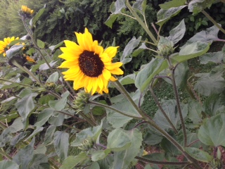
The sunflower
Nearly everyone knows that bright yellow sunflower. There are many different sorts which one can to cultivate.
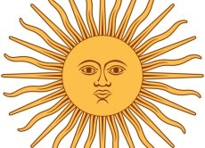
Originally the sunflower comes from America. The Incas began to use it around 1000 before Christ. Also they admired the sunflower as image of its God Inti. The Sun god Inti was represented as a golden disk with human face.
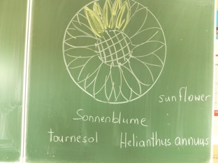
(Source: wikipedia) Around 1530 then Spanish sailors brought the seeds of the sunflower from America to Europe.
In many languages one finds the word „sun“ in the name sunflower. In German the flower is called „Sonnenblume“, in French she is called „tournesol“, in Luxemburgish „Sonneblumm“ and in Italian „girasole“. The sunflower got the name, because it follows the run of the sun from the east with the inflorescence to the west. It drives itself thus with the sun. In the night the bud returns again eastward.
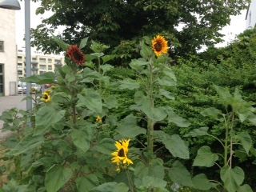

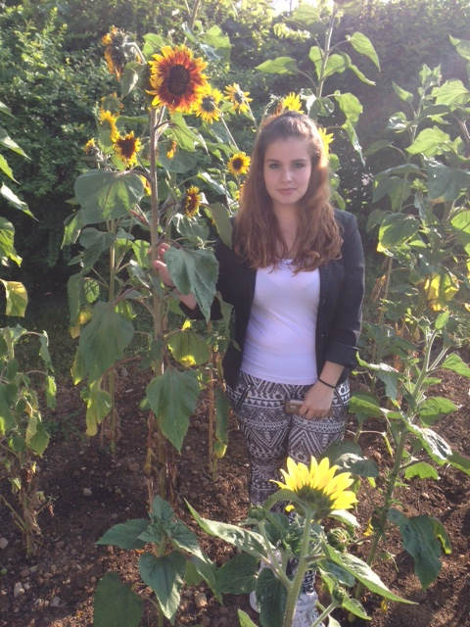
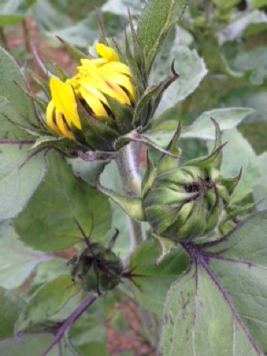
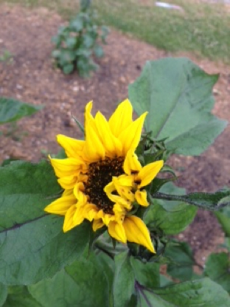
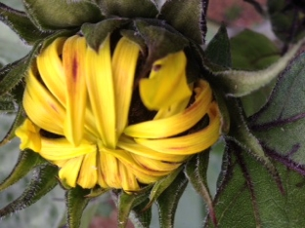

The sun comes from the family of the cart bloom plants. Their bloom looks as if it would be embedded in a cart. The bloom has on the average a diameter from 20 to 50 cm. The heart-shaped yellow leaves can become long up to 40 cm.
Some sunflowers can become up to three meters high. So that the sunflower can grow well, it needs very much water and fruitful, damp earth. In March one can prefer the sunflower in pots. In April the seeds are sown directly in the open land. After approximately 150 days the sunflowers can be harvested. Most sunflowers bloom in late August through September.
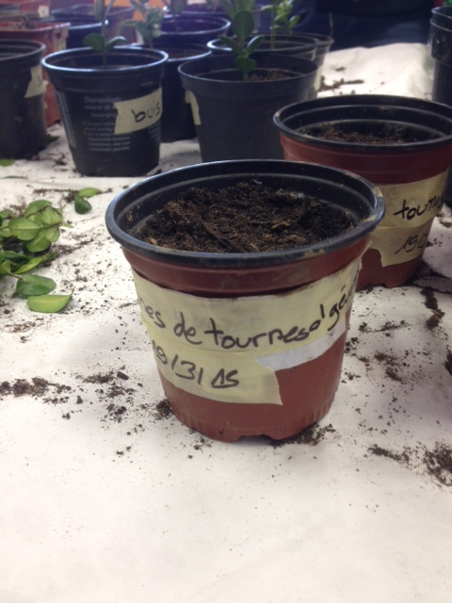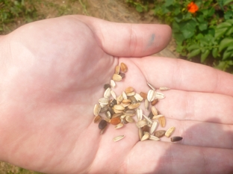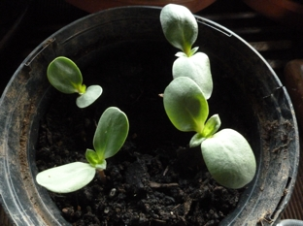

The use of the sunflower seeds is known since the 17th Century. At this time they were used in baked goods as bread and cake or roasted as replacement for coffee. Only starting from that the 19th Century one began to use the sunflower as oil plant. From the seed of the sunflower one can win sunflower oils for cooking oil and margarine.
In addition, one can eat the seeds in such as snack food and use them pan-roasted in salads. In the winter one can use the cores also as bird and animal fodder.
Also in the art the sunflower played a role, like in the works of the painter Vincent Van Gogh. Vincent van Gogh liked the yellow sunflowers very much. During a stay in Arles in Southern France Vincent van Gogh painted it more frequently and completely differently. Humans around the world love to today his flower pictures, although Van Gogh died more than hundred years ago.
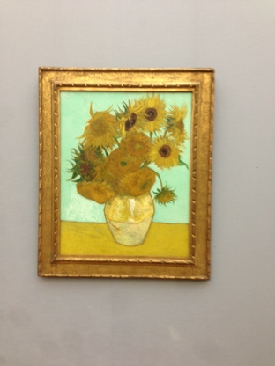
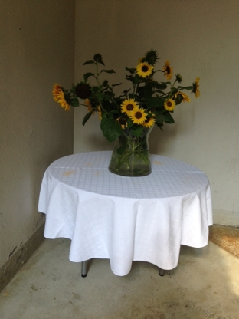
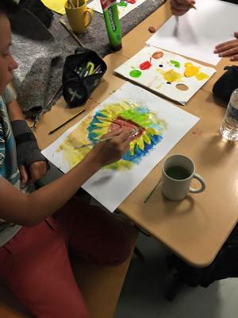

On the basis of the information in the text you can fill out now the following template.
Underline with a yellow pen the correct answers in the text.
Family
Leaf form
Leaf colour
Origin
German name
Sowing
Harvest
Use
I find that still interesting | 