Sun powered heater made by Majan 9G and Paavo 9F

Materials: plywood, aluminum cans, cardboard box, black paint, glue, computer cooler, electric engine, copper wire, soldering tin, nails, clean plastic, hot glue

Tools: soldering iron, hammer, drill, hot glue gun.

Main principle: The sun heats the cans and air flows through the cans and air heats up. Fan system is for boosting air flow.

Dimensions: 620mm x 1050mm x 100mm

Phase 1

In phase 1 we planned the project and we collected aluminum cans.

Phase 2
In phase 2 we collected and cut the plywood to the correct dimensions.

Phase 3
In phase 3 we drilled can sized holes in to our can holder.

Phase 4
In phase 4 we fitted a cardboard box onto our base plywood and we painted it black.

Phase 5 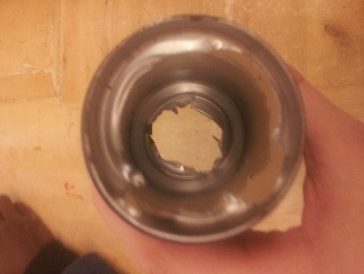
In phase 5 we ripped the lids and the bases off our cans.

Phase 6 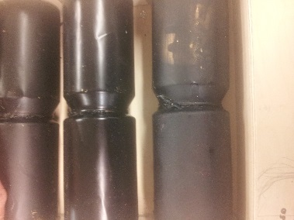
In phase 6 we glued the cans together and painted the can towers with black paint
Phase 7
In phase 7 we nailed the frame together and to the base.

Phase 8
In phase 8 we nailed the can holders to the frame.

Phase 9
In phase 9 we glued the can towers to the can holders.

Phase 10
In phase 10 we made the fan system from computer cooler and electric engine.

Phase 11
In phase we put on the clear plastic over the cans.

Final phase 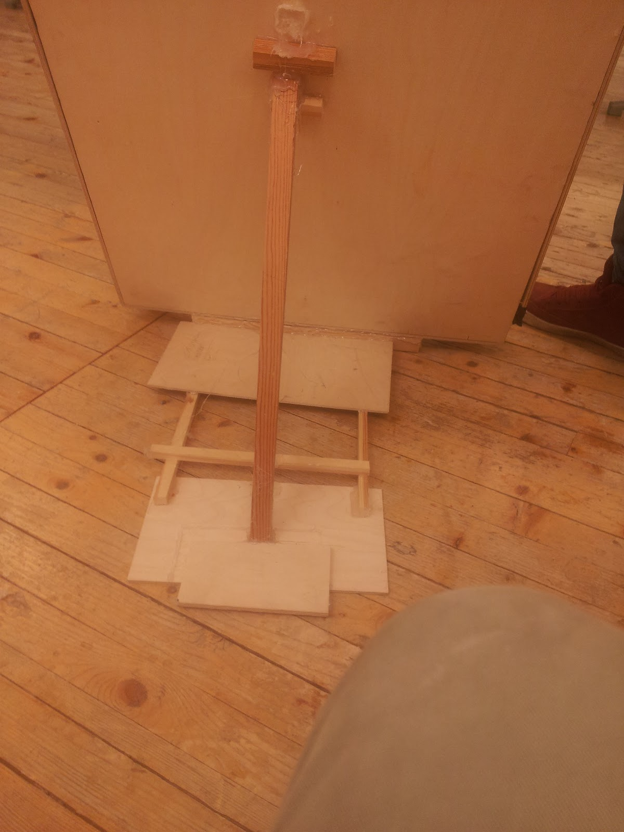
In this phase we made a stand for our heater.

